Item 1 | $
Item 2 | +$
Total
Item 1 | $
Item 2 | +$
Total

Item 1 | $
Item 2 | +$
Total

Item 1 | $
Item 2 | +$
Total
Item 1 | $
Item 2 | +$
Total

Item 1 | $
Item 2 | +$
Total

Item 1 | $
Item 2 | +$
Total

One package of Pokemon cards
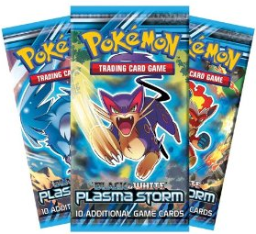
$2.99

3 Headbands
$5.95 (total not each)

Series of Unfortunate Events
Boxed Set
$74.58

Chocolate for Miss McKendrick
$1.90

Minecraft book
$7.88

Weird but True! book
$4.00

Pair of socks
$2.29

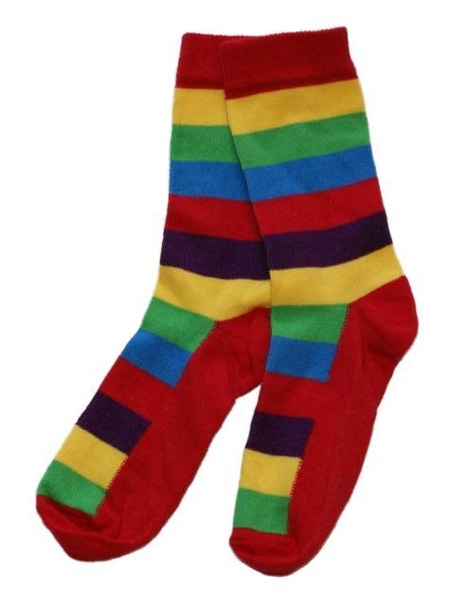

A new toothbrush
$1.35

A new homework folder
$0.45

A large pizza
$7.99

A box of cereal
$3.50

Apple Juice
$2.29

A birthday present for your mom $7.60

A pet hamster (if your parents allow it first) $32.99

A hamster cage, food and toys
(for at least the first 2 months)
$56.00

A new t-shirt
$9.99

A brand-new DVD
$14.99

A new pair of shoes (and a free story about a bear)
$19.99

A new pair of khaki pants
$17.95
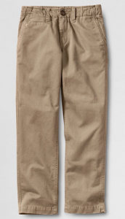

A school uniform belt
$12.99

