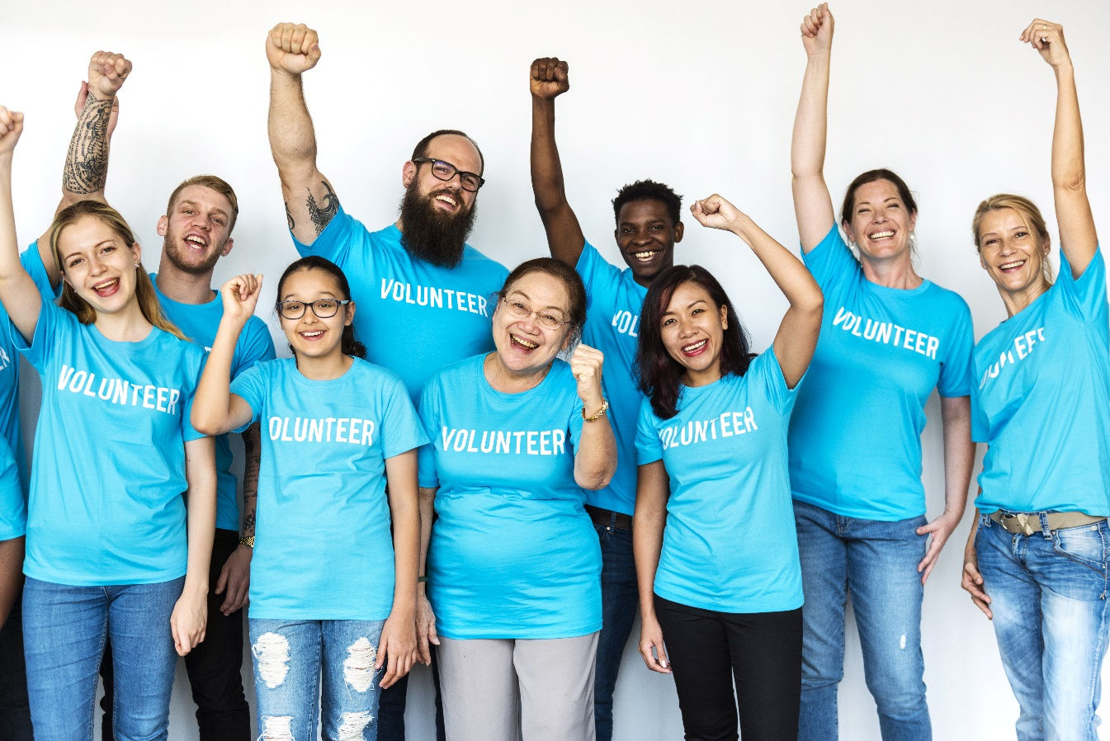
 |  | JoNI | December 2021  Thought Paper: Why I Volunteer
 |  | The Journal of Nonprofit Innovation
AUTHOR
Demi Glad (Sintz)
__
Topics
Volunteerism
__
Article Type
Thought Paper
__
Nonprofit Affiliation
Nonprofit Volunteer

Why I Volunteer: Building Communities, Developing Empathy, and Finding Greater Purpose and Appreciation in Life
-- Thought Paper by Demi Glad (Sintz)
About the Author: Demi Glad currently works as a recruiting coordinator and marketing consultant at Expedited Talent. She was married in October 2021. In her free time, she loves hiking, spending time outdoors, usually barefoot. She always makes time to volunteer with nonprofits she feels will make an impact in the world. Her brother has a rare disease called Dravet Syndrome, and he is the reason why she started volunteering. She has since developed a passion for advocacy work and there’s a special place in her heart for special needs children. Demi plans on getting her degree in communication where she hopes to do full time work for nonprofits.

WHY I VOLUNTEER: Building Communities, Developing Empathy, And Finding Greater Purpose and Appreciation in Life
Thought Paper By Demi Glad (Sintz)
I began working with nonprofit organizations as a youth advocate for Epilepsy Awareness, from there I became a Director of Fundraising events for an organization that assists families with the expenses of training and matching with a service dog. Later I spent 18 months in L.A County volunteering in the community and leading youth seminars on positive social media use and training community leaders on the importance of family history and making it an accessible tool in their communities. Now I am a marketing advisor at WikiCharities, a platform that makes collaboration between organizations possible and increases accessibility to care for those in need.
My first experiences volunteering included many engagements with those in the special needs community. I spoke with and advocated for those with Epilepsy and children with severe rare diseases. I witnessed first-hand the hardships these families went through, including my own. I watched as families struggled financially, medically, socially, you name it. Despite their hardships, you’d be amazed at the joy that these families radiated. When the world seemed to fail them, they united and advocated for each other and supported each other. They advocated for each other fiercely. As I sought to spread Epilepsy awareness, I saw a lot of rejection due to fear of the unknown. The miracle was that I saw even more support, which led to specialized seizure first aid trainings throughout the state of Utah and laws passed that are still considered a historical accomplishment.
Volunteering teaches you to immerse yourself in the uncomfortable and make an impact. When you do this, you are forced to turn the focus away from yourself. One of the greatest lessons I’ve learned is that everyone is struggling in their own way and there is always someone that has it worse for you. I learned to appreciate the little things and see the value and goodness of the life I had. Volunteering gives you the opportunity to listen and understand the reality of others and eventually you learn to love without a veil of judgment.
While volunteering in California I quickly came to realize the need for community. Everyone yearns to feel like they belong and wants to be surrounded by others who understand them. For some people that
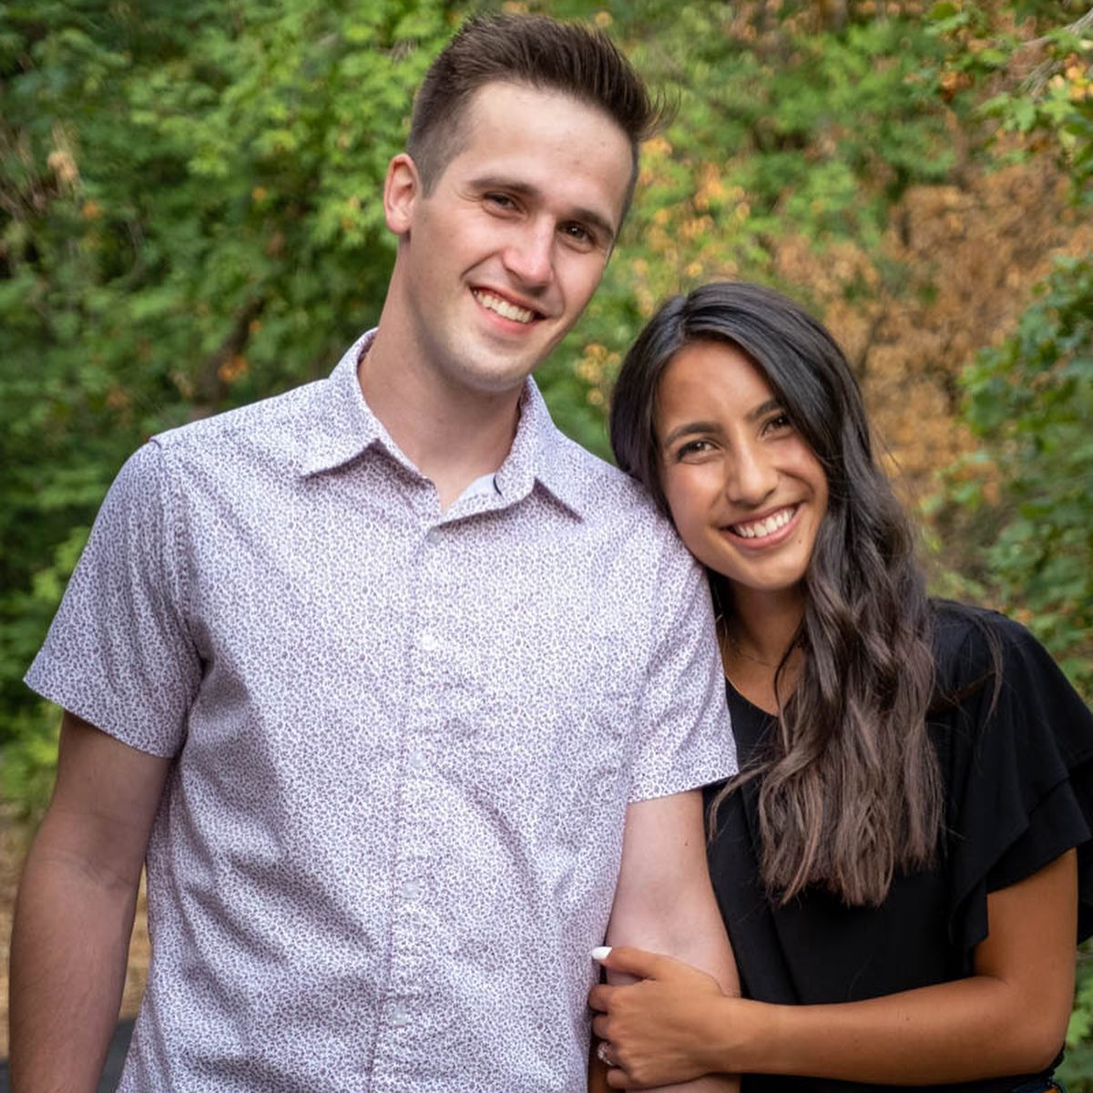
can be learning about their families, others it can be finding support groups, and in some cases, it can be making their cause known so they can find the help they need. Nonprofit organizations strengthen their corresponding communities, and with community comes greater purpose. Whether that is advocating, assisting, uniting, building, etc. volunteering with a nonprofit organization you relate to will lead to the positive impact on the community.
The experiences I’ve had working with nonprofit organizations has set the foundation for the current course of life. Early on I was taught to be a voice and to advocate and I will forever be an advocate for those without a voice. There is a sense of fulfillment you gain when serving others. The more I work with different organizations, the more I yearn to help others. My volunteer experiences helped me to understand that there is a purpose and a place for every person in every circumstance. Volunteering is a way to put good into the world. People are meant to help other people. When we collaborate and work to support each other, the world becomes a better place. This is why I volunteer.

